Assignment 2

Part A

1. Prints Hello, World!
2. Assigning the value Productive to the variable name
3. Creates a new file named file.txt
4. Lists all files including the hidden files
5. Removes file named file.txt means deletes it
6. Copies file1.txt content in file2.txt which means the content of file2.txt get overwritten
7. Changes the permission through change mode 755 as 7 means the owner (u) has rwx and 5 means the group (g) has read and execute permission and 5 means the other users (o) has read and execute permissions.
8. grep finds the “pattern” in file.txt along with their line number
9. send termination signal to the process with that PID.
10. Make directory mydir, enter into mydir and then create a file name file.txt then writes Hello, World! In file.txt and then output the things written in file.txt
11. Firstly, ls –l will show the details of the files in the directory but it gets filtered out where the file name has .txt
12. Show the content of both file by combining both and then sorts it and after that displays only the unique elements
13. Firstly, ls –l will show the details of the file in the directory but later displays only those file who are the directories which is in the starting of the permissions “d”.
14. Searches the word “pattern” in all the files given at the location
15. Combines content of both the files, sorts them and prints only the duplicate values that appeared but only once. Ex : If file1.txt and file2.txt have in combination apple, banana, mango, banana, apple then only apple and banana will be printed. (All the names are in different line)
16. Changes the permission through change mode 644 as means the owner (u) has rw and 4 means the group (g) has read permission and 4 means the other users (o) has read permissions.
17. cp –r source_directory destination_directory copies the entire directory from source to destination
18. Searches at the given path with all the file names ending with .txt
19. It changes permission of owner by adding execute permissions
20. echo $PATH prints the environment variables which store directories

Part B

Identify True or False

1. True
2. True
3. False
4. True
5. True
6. True
7. True
8. True

Identify the incorrect commands:

1. 2. 3. 4. 5

Part C

1. The steps are as follows :
2. vi file1.sh
3. Esc + i
4. #!/bin/bash

echo “Hello, World!”

1. #!/bin/bash

name = “CDAC Mumbai”

echo $name

1. #!/bin/bash

echo –n “Enter a number”

read var1

echo $var1

1. #!/bin/bash

echo –n “Enter the first number”

read a

echo –n “Enter the second number”

read b

((sum=a+b))

echo “The sum of the numbers are $sum”

1. #!/bin/bash

echo -n "Enter number:"

read num

if [[ ( $num -lt 10 ) && ( $num%2 -eq 0) ]]; then

echo "Even number"

else

echo "Odd number"

fi

6.

#!/bin/bash

for var in 1 2 3 4 5

do

echo $var

done

OR

for i in $(seq 1 5)

do

echo $i

done

7.

#!/bin/bash

i=1

while [ $i -le 5 ]

do

echo $i

((i++))

done

8.

#!/bin/bash

if [ -f "file.txt" ]; then

echo "File exists"

else

echo "File does not exist"

fi

9.

#!/bin/bash

echo -n "Enter a number: "

read a

if [ $a -gt 10 ]; then

echo "Number greater than 10"

else

echo "Number lesser than or equal to 10"

fi

10.

#!/bin/bash

for i in $(seq 1 5)

do

echo "Table of $i"

for j in $(seq 1 10)

do

echo "$i x $j = $((i*j))"

done

done

11.

#!/bin/bash

while true

do

echo -n "Enter the number: "

read a

if [ $a -lt 0 ]; then

break

else

echo $((a*a))

fi

done

PART E

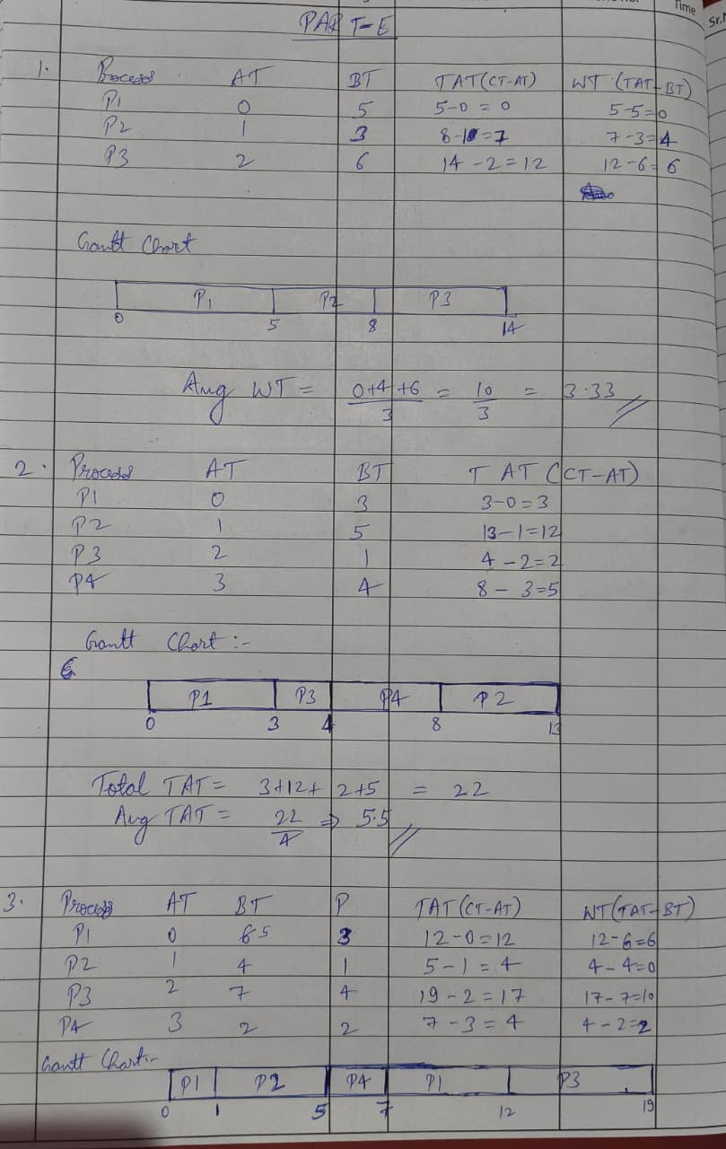

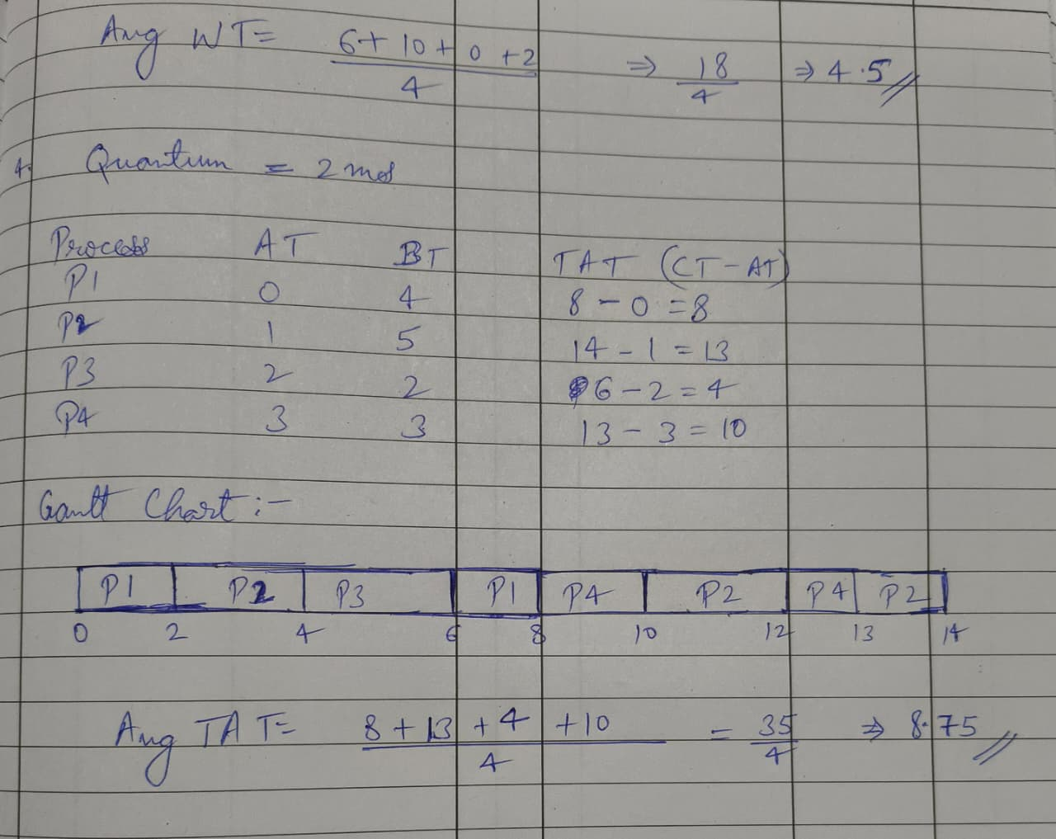

5.

The final value of x in both the parent class and child processes will be 6 because after the fork() call the both the copies are incremented independently.